12v-5v component selection for : TPS51375LVBHR

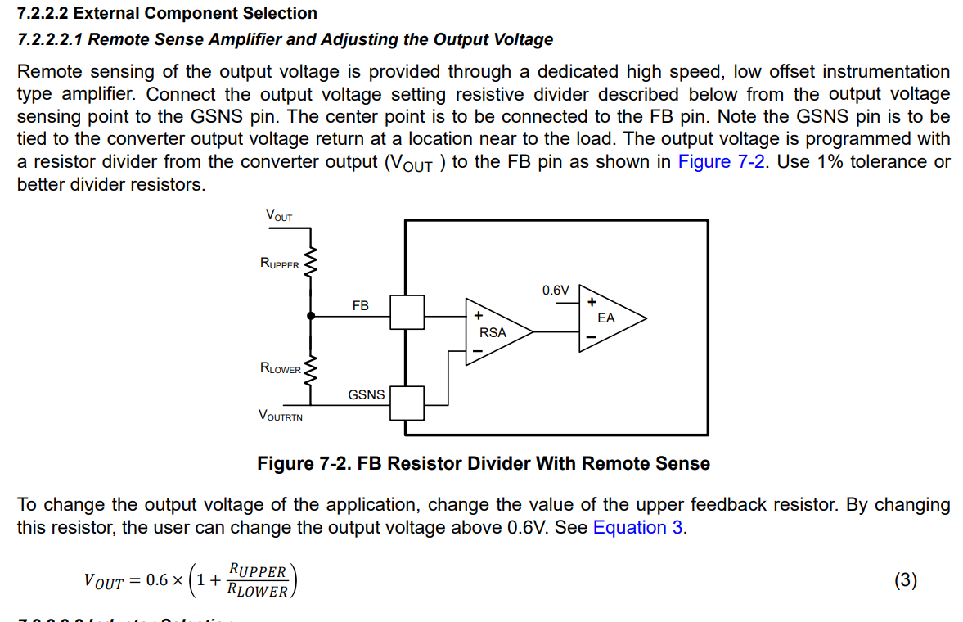
V_out = 0.6( 1 + 154/21) = 5V out

